**WATERFALLS AND WOODS: MAPPING DESIRE PATHS AT**

**JESSAMINE CREEK GORGE**

**  
A REPORT MADE IN PARTIAL REQUIREMENTS TO**

**THE CLASS: GEO-499**

**RESEARCH SEMINAR**

**JACOB BAME  
DR NICK LALLY**

**30 APRIL 2021**

**INTRODUCTION**

Jessamine Creek Gorge Nature Preserve is the most recent addition to the county’s growing number of public preserve trails. Since its acquisition, these trails have continued to grow in popularity among outdoor enthusiasts from counties across the Commonwealth of Kentucky. However, this increase in preserve interest has not been without repercussions. Surprisingly, many of the Gorge’s most exciting sights (including the staggering 75-foot Overstreet Falls) are located off-trail. This has led to many visitors venturing off-trail and down the steep slopes of the Gorge, blazing what is known as “desire paths” as they go. Desire paths can be understood as a path that forms from frequent travel cutting through a space in an unintended manner. Moreover, they have been described as illustrating “the tension between the native and the built environment and our relationship to them… [Desire paths] indicate [the] ‘yearning’ of those wishing to walk, a way for ‘city dwellers’ to ‘write back’ to city planners, giving feedback with their feet”. (Bramley, 2018.) Desire paths at this preserve have slowly grown over time as increasing numbers of guests travel along them.

Interest in these off-trail features is understandable, but there are a few issues that these desire paths present. First, guests are put at risk of falling and injury. Jessamine Creek Gorge (as the name would imply) is home to many steep cliffs which are often heavily saturated. This is largely the result of the preserve’s sharp elevation changes paired with the region’s karst landscape which has been responsible for statewide difficulties in every field of planning from remote trails to urban epicenters. (Florea, 2002. p. 61.) As more foot traffic occurs in these areas, chances of guests falling and injuring themselves not only increases, but vegetation and stability of the loose soil and rockfaces (especially near Overstreet Falls) similarly decreases. “Impact occurs wherever use occurs… [suggesting] that the decision facing recreation managers is how much impact is acceptable – not whether or not to allow impact.” (Cole, 2004. p. 43). Moreover, some of these desire paths traverse private property not owned by the county, restricting county jurisdiction to maintain and protect segments of these paths. This deterioration completes a feedback loop where guests are at higher risk of injury as desire paths continue to be traveled.

Erosion and the deterioration of vegetation caused by desire paths is not a localized issue. One study conducted by Farrell (2001) in Aconcagua Provincial Park found informal trails (i.e., desire paths) to have resulted in the loss of 5.2% of vegetation within the total study area. Several of these desire paths cut through park ecosystems, dividing plant and animal habitats into broken sections. “In addition to the direct loss of vegetation by trails and other infrastructure, there was extensive fragmentation caused by the trails resulting in 89 separate fragments.” (Farrell, 2001. p. 60.)

Jessamine Creek Gorge is home to numerous rare or endangered plant and animal species and is considered one of the ten most ecologically valuable areas in Kentucky. (Kocher, 2015.) The preserve provides a unique and sensitive habitat for many of these species and any outside disturbance to their habitats can be detrimental. Vegetation such as *Paxistima canbyi* (Mountain-lover) and *Phlox bifida ssp. stellaria* (Cleft Phlox) are present in the preserve monitored by the State Nature Preserves Commission. Rare reptiles such as the *Eumeces fasciatus* (five-lined skink) and *Agkistrodon contortrix* (copperhead) can be found along with several bat species like the *Corynorhinus rafinesquii* (Rafinesque's Big-eared Bat), *Myotis sodalis* (Indiana bat), and *Myotis grisescens* (gray bat). These bats have been specifically reported around Overstreet Falls and Overstreet Cave and are known to be very uncommon in the region. (Campbell et. al. 2010. pp. 53-54, 64-65.) Efforts have already been made to restrict guests from entering these areas by means of ropes blocking desire paths, and preserve signs making guests aware of the rare and endangered species within the park. Despite these efforts, damage is still occurring to rare species habitats at the Gorge. In response, the county fiscal court has considered closing off public access to the preserve. (Patrick. 2020). Protection of these species falls on the county fiscal court since it holds ownership of the preserve.

In this research project I will examine and record where guests are creating desire paths at Jessamine Creek Gorge. My argument is that many of these desire paths are forming where “features of interest” are located which attracts guests to these areas. By critically analyzing where desire paths are forming, I created new trail proposals with corresponding GIS data. These proposals aim to increase safe guest accessibility to features of interest while reducing any risks to uncommon and rare species located at the preserve. This project could therefore be used for the efficient and economic benefit of the Jessamine County Fiscal Court in maintaining and improving Jessamine Creek Gorge. This is because social desire path analyses “use evidence of behavior that has already patterned responses (rather than collecting new data on preferences or attitudes).” (Nichols, 2014. p. 8).

To answer these questions, on-site and online data collection was necessary. This included mapping official trails at Jessamine Creek Gorge alongside desire paths and properly defining points of interest within the preserve. Furthermore, Jessamine County residents Mr. John Howard and Mr. Timothy Powell were both interviewed and kept in correspondence during the making of this report. John Howard serves as Nicholasville’s Parks and Recreation Deputy and is currently operating as head organizer for the Jessamine County Trails Association. Timothy Powell is an outdoors enthusiast who has volunteered and aided in trail blazing, maintenance, and conservation for over 20 years in Jessamine and nearby counties. These men were both instrumental in educating me on many relevant topics pertaining to my report as well as providing and/or pointing me towards resources I could use to further my research.

I first met with Howard for an interview on March 2, 2021. Our discussion began with the Jessamine County Trails Association and its role at Jessamine Creek Gorge. He explained to me that while the Trails Association is the primary contact for all information regarding the preserve, it consists of volunteers and has waned in activity in recent years, especially since 2020. Trails are largely maintained through volunteer work, which can be difficult to coordinate once time and money come into question. Howard explained to me that many of the trail markers (including wooden arrows and the trailhead sign at the front of the park) were made and put in place by him personally as he is passionate about the upkeep of the preserve.

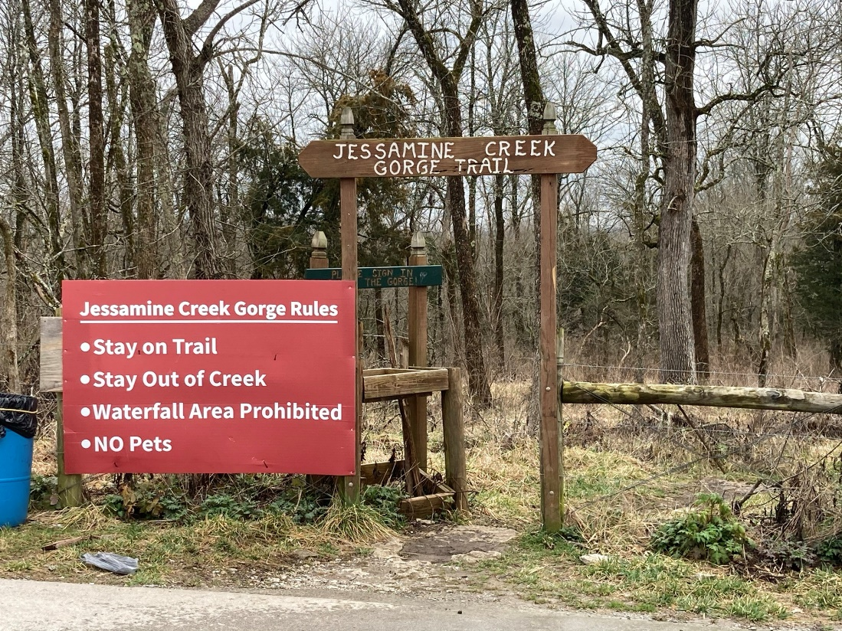

Howard firmly believes that Jessamine Creek Gorge is one of the county’s greatest gems of beauty and its most visited attraction. To illustrate this, he provided me with a visitor report on the preserve that took place between July 14, 2017, through December 31, 2017. A logbook was set-up for guests to sign with their name, hometown, and any comments they had. During this time, hundreds of signatures were recorded representing 38 Kentucky counties, 27 states, and 4 continents. A total of 128 comments were collected, almost all of which were extremely positive. Many stated that it was a first time visit or that they were visiting on a special occasion such as a birthday, holiday, or while visiting family in town. Others commented on the beauty of the preserve, stating that it was “beautiful and very clean,” or “the creek is gorgeous.” Several comments mentioned children as young as three and four years old that were brought along, and that the preserve is “Great for family.” Some Jessamine County residents called it the “Red River Gorge of the Bluegrass” and “Best tourist attraction in the County!” Out of all these comments, the only negative one I could find simply requested that the road to the preserve be made wider. It should that there were likely even more comments, as during this time five logbooks were stolen from the preserve.

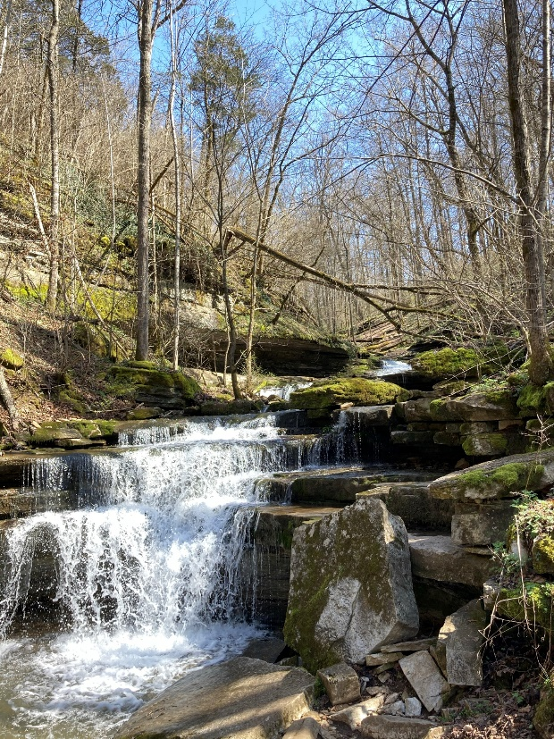

Howard felt that one of the biggest issues plaguing the preserve was poor trail planning. He explained that the original and official trails were blazed quickly and out of convenience and did not take features of interest into much consideration. He attributed the lack of interesting features visible from the official trail be the largest reason desire paths have formed at Jessamine Creek Gorge, stating, “When folks hear that there’s a 75-foot waterfall just down the street from where they live, they’re going to want to go see it. It doesn’t matter if it’s on the trail, they’re going to find a way to see it. People call me several times a week asking if they’re allowed to go see the waterfall, asking about bringing their dog to the park, asking about all sorts of things the county has said are ‘rules’. The message has been unclear for years.”

This topic of interesting features at the preserve kept appearing in our interview. This led me to question what qualified as a *feature of interest*, since “topic modeling” a firm definition would serve as an excellent method “for gaining an understanding of what is important in a place.” (Martin, Schuurman, 2020. p. 1341.) An idea on how to do this was to interview preserve visitors on various days and ask what locations in the preserve they saw or came to see. From these interviews, a list could be collected of locations that came up regularly. Unfortunately, this plan never came to fruition as it would be rather unsafe given current Covid-19 protocols at the time of this project. As I began searching for alternative methods, I was

directed towards a visual research method such as those discussed by Gillian Rose. Rose writes, “‘Visual research methods’ are methods which use visual materials of some kind as part of the process of generating evidence to explore research questions. These methods are diverse, and their diversity inheres in both the sorts of visual materials they work with, and in the procedures to which those materials are subjected.” (Rose, 2014. p. 25.)

**METHODS**

By undertaking a visual research method, I was able to identify what visitors viewed as features of interest simply from their personal photography. I set out to do this by utilizing the #jessaminecreekgorge tag on Instagram, a tag commonly used by visitors when posting images of their time at the preserve to social media. “The analysis is very attentive to the content of the photographs, as well as the captions provided by the photographers, but only to their content: to what is literally on show. The significance of the photos is seen to rest on what is pictured, not how it is pictured… This focus on visibility rather than visuality sidesteps the understanding of images as meaningful objects central to symbolic and communicative activity that is core to many theorizations of contemporary visual culture.” (Rose, 2014. pp. 29-30.)

As of April 12, 2021, there were 1,175 posts using the #jessaminecreekgorge hashtag. By sifting through these corresponding images, I was able to identify and create a list of commonly pictured features within Jessamine Creek Gorge.

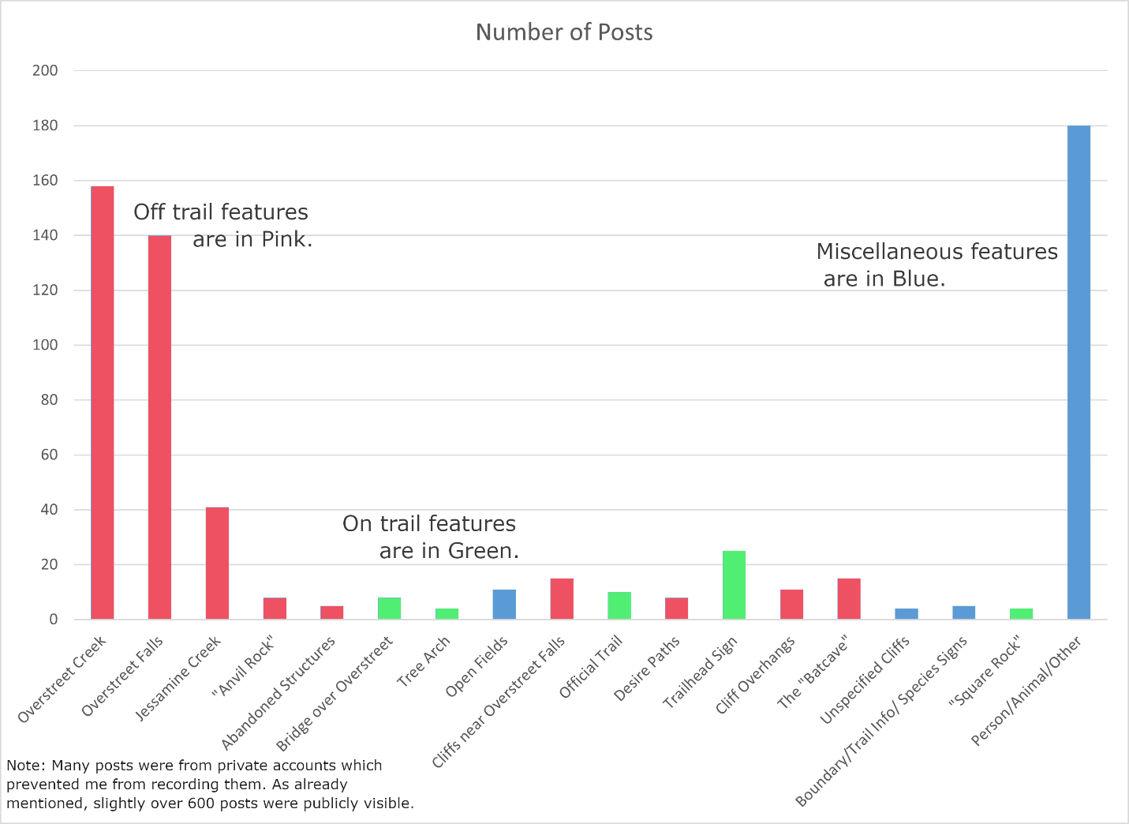  
Figure 1: Number of Instagram Posts by Feature Type by Jacob Bame.

A total of 14 identifiable features were documented with nine off-trail features and 5 on-trail features. (Figure 1.) The locations of these figures in relation to each other and the preserve can be found in Figure 2.

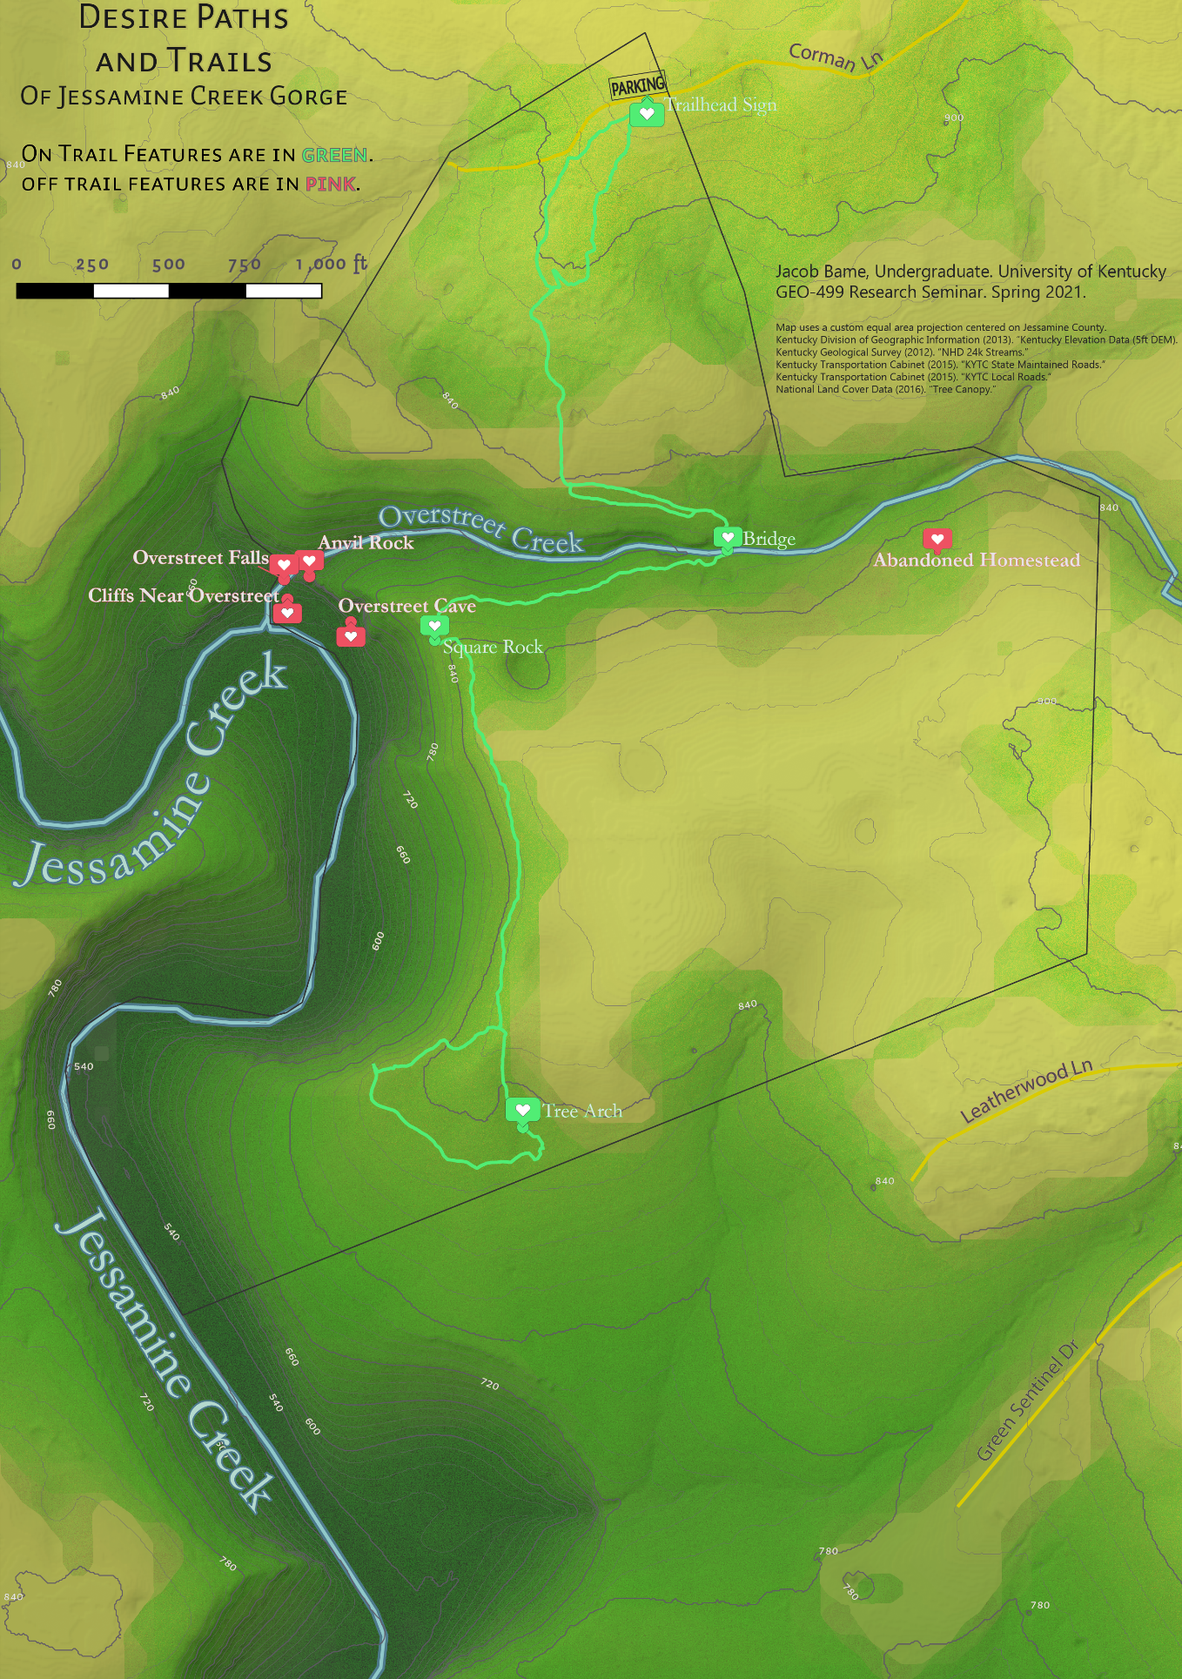  
Figure 2: Map of Instagram Features at Jessamine Creek Gorge by Jacob Bame.

Cataloging and mapping of desire paths was equally necessary to perform my research. After searching online and meeting with John Howard, I found that no publicly available GIS data existed related to Jessamine Creek Gorge except for land parcel data from the Jessamine County PVA office. Upon further examination, I found that this map was powered by Esri (indicating there might be GIS data available for download), but no link existed on the site, nor could anyone I contacted at the PVA office find a way to get me this data. As a last resort, I was able to find a polygon boundary of Jessamine Creek Gorge on OpenStreetMap which would come in handy for identifying desire paths that traversed outside of the preserve’s boundaries.

I then set out for Jessamine Creek Gorge to collect trail data using Avenza Maps App. Avenza functions as a powerful GIS tool that allows users to import their own pdf copies of maps onto their smartphones and view their location on the map in real-time, as well as plot data such as points, paths, and polygons which can be exported in .kml format. By hiking all trails and desire paths, I would be able to generate trail layers for later analysis in QGIS.

With John Howard’s permission, I visited Jessamine Creek Gorge on two separate days: March 12 and March 20. My visit on the 12th was primarily to examine where desire paths may shoot off from the main trail and take pictures of the preserve in rainy weather conditions. I collected path data was on March 20th by hiking every desire path I was able to find. Additionally, more pictures and video were recorded.

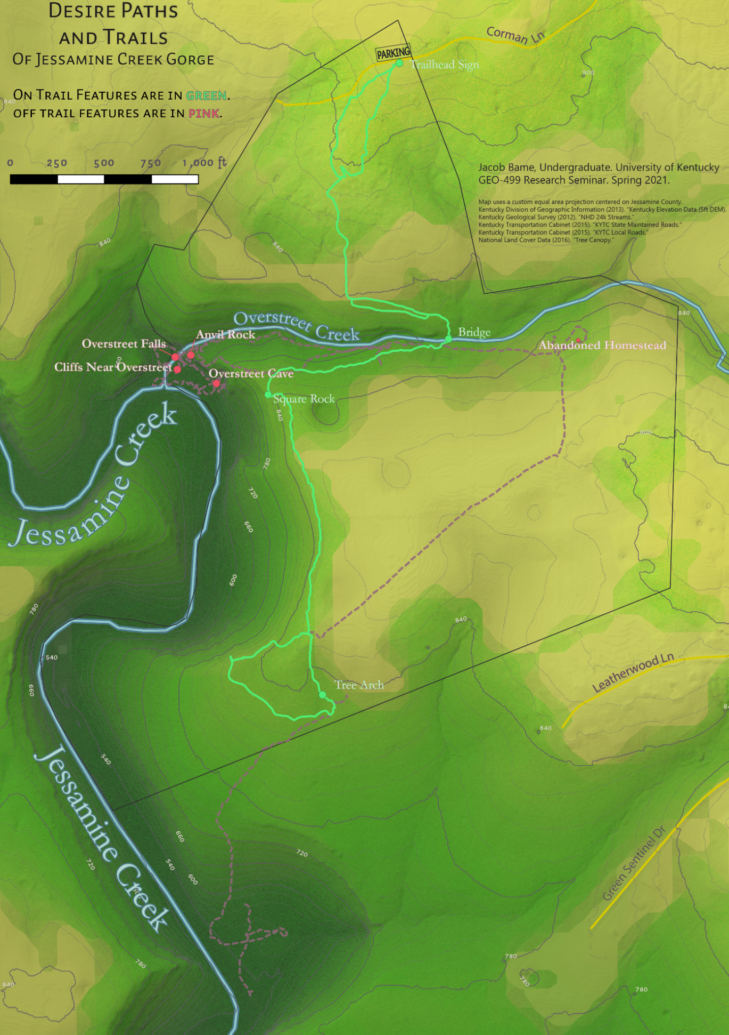Figure 3: Map of Desire Paths at Jessamine Creek Gorge by Jacob Bame.

**RESULTS**

After conducting my field research, I found that there many more desire paths than I originally anticipated, but that the combined length of the desire paths I found was nearly double the length of the official trail. While the official trail has a length of approximately 1.28 miles, but desire paths totaled in at 2.02 miles in length. The second discovery made was that desire paths almost always traveled towards the off-trail features of interest catalogued from the Instagram posts. Overstreet Creek and Overstreet falls were disproportionately photographed along with wildlife found at the preserve. (Figure 1.)

The data collected from my field research provides some fascinating insights as to how Jessamine Creek Gorge is being explored by visitors (such as the features of interest) With some desire paths even rivaling the quality of the official trail. On the main desire path leading to Overstreet Falls, visitors even put safety ropes along a steep path for ease of access. In other areas, barriers put in place to prevent visitors from taking desire paths have appeared to be heavily weathered or intentionally moved or obstructed. Some well-maintained desire paths include safety ropes and allow visitors to enjoy park features like Overstreet Creek more safely.

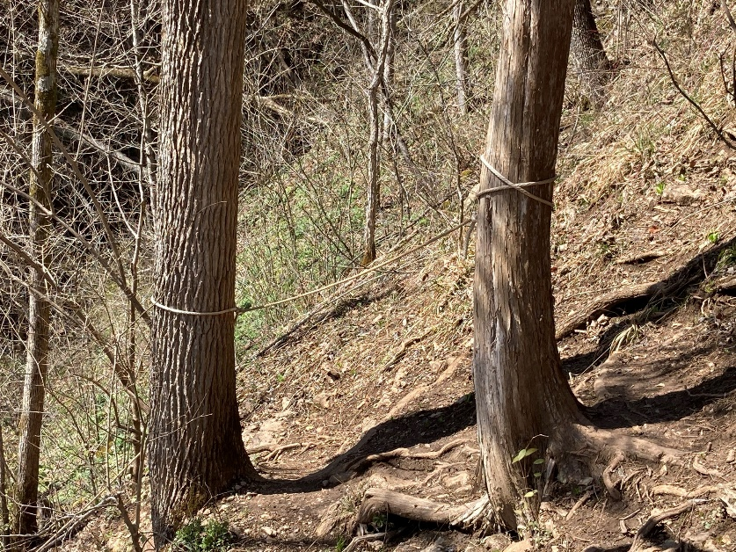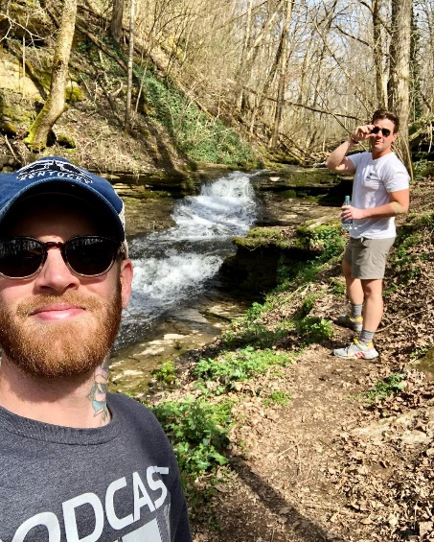

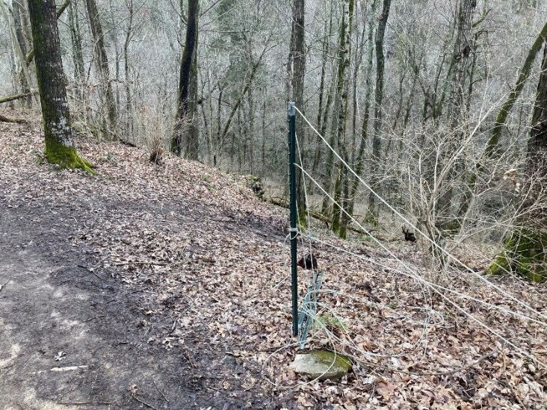

This desire path leading to Overstreet Falls includes a safety rope along the steep incline change

A desire path branches off from the main trail here. Although there was once a barrier to prevent visitors from traveling this way, it has since broken partially and been moved out of the way.

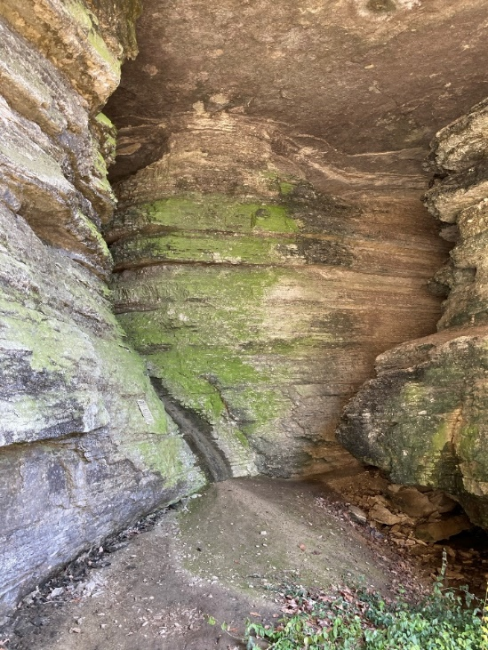  
Entrance to Overstreet Cave

The fiscal court (as previously mentioned) holds ownership of the Gorge and is thereby concerned with protecting rare and endangered species within the preserve’s boundaries. Currently, the biggest area of environmental concern is Overstreet Cave, affectionately referred to as the “Batcave” by some locals. This cave has a large entrance just a few hundred feet away from Overstreet falls and is home to the endangered Indiana bat from spring through autumn. Under the Federal Endangered Species Act, entering the cave is prohibited from April through October to reduce environmental stress and ensure bats continue to return to the site each year. Given that this cave appears in multiple social media posts and a desire path leads directly to the entrance, there is concern whether warning signs are enough to deter visitors from entering the cave.

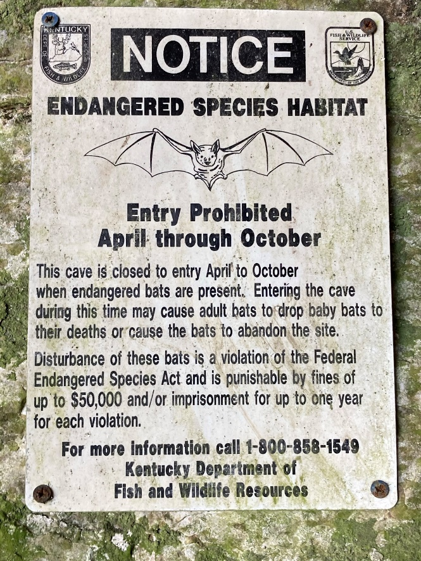

A second issue desire paths have created is that they lead guests out of the preserve’s boundaries and onto private land. This takes place on two separate desire paths that both lead to Jessamine Creek, with one path stretching almost half a mile away from the property. Naturally, this has raised concerns among property owners regarding trespassing, vandalism, and legal responsibility of the property owners if someone were to get injured on their land.   
**DISCUSSION**

When I presented these issues with John Howard, he felt that much of the concern from the county stemmed from the complaints of local property owners. The preserve has been publicly advertised with an official website since 2015. However, the county purchased this property ten years prior in 2005. (Jessamine County PVA Office. 2021.) Howard argued that in these first ten years of county ownership, the preserve was visited only by those who knew of its existence from word of mouth, which meant Corman Lane (the only road to take to get to the property) experienced very low traffic. Since that time, he stated that traffic has increased considerably on this one lane road, especially on dry sunny weekends when visitors flock to the preserve.

A study conducted by Henry Howell et. al. (1976) found evidence that treated sewage water from Lexington, Nicholasville, and Wilmore may play a much larger role in environmental degradation. Treated water is augmented into both Jessamine and Hickman creeks and plays a significant role bacterial content ten times higher than state standards and fifty times higher than public water supply use. (Howell, 1976. p. 8.) Vegetation changes were also documented with increased algae and fungi both appearing in increased quantities where treated water was present. (Howell, 1976. p. 8.)

When asked about safety concerns, Howard admitted that without a proper trail to Overstreet Falls, visitors were at risk of injury, especially if they were to take the cliff face down. I briefly discussed the accident in 2019 when a woman fell 50 feet down the cliff near the falls. (WKYT, 2019.) “With how steep that cliff face is, it was only a matter of time before someone got hurt.” However, Howard also argued that with approval from the fiscal court and proper planning a safe trail could be made leading to Overstreet Falls that avoided the risky desire path route altogether.

My interview with Timothy Powell provided some insight as to how desire paths might be successfully combatted.

“It’s part of what I call trail philosophy, but generally you can understand that where one goes, another will follow. You’ll have some adventurous person go off trail, maybe with a location in mind or just to explore. While they’re traveling along, they’re squishing down plants and grass, moving sticks and leaves… they’re leaving a subtle but small trail. Now for me personally, I always get interested when I see a deer trail… (which is usually a lot less defined than a human trail) and will sometimes follow it to see where the deer went. But if I’m not careful about where I tread, someone else may come along later and go ‘hey, it looks like there’s a trail here!’ and follow the path I just made. This is just gonna keep making the trail bigger and bigger until pretty soon you have a ton of people taking that deer path.”

As Powell explained it, desire paths were likely being started by a very small number of people but were growing over time as more individuals found interest in them. However, he did not think that this meant there was no way to solve the desire path problem. We decided to visit Tom Dorman State Nature Preserve (Powell’s favorite local hiking spot) where he showed me where desire paths once were that he had hidden the previous weekend.

“The Boy Scouts have said it for a hundred years: leave no trace. It took me maybe an hour or so, but I just moved leaves and fallen branches over the path that was forming here and look at it now! You can’t even tell anything was there. And now that it’s been covered, no one that’s walked by has thought ‘hey I wonder where this goes?’ and it’s stopped being traveled. Now, this isn’t gonna work if people know there’s some big waterfall or cliff or something just down the way, but you’d be surprised how easy it is to keep most people on the trail.”

By covering up existing desire paths with vegetative debris like leaves and branches, Powell was effectively able to hide some of the minor desire paths at Tom Dorman Preserve. This appeared to have kept visitors off the path (albeit only for a week). These specific desire paths, Powell explained, did not lead to what he thought were features of interest. The question remained as to how effective this restoration method would be at Jessamine Creek Gorge.

Finally, an examination of similar projects led me to Erica Luckert’s mapping of desire paths in Edmonton, Canada. Ultimately, Luckert found that desire paths within Edmonton were usually made in haste when traveling to a specific location or cutting across space. During her research, she discovered a nature hidden within desire paths. “When I walk, looking for desire lines, I’m astonished by how much more I notice – not just paths, but whole worlds – fields of wildflowers in abandoned lots, secluded clearings in a dense grove of trees. With that point of view, my map of the city opens up, and I can see more possibilities than just routes from one point to another – I see the spaces in between as well, and I want to know them.” (Luckert, p. 326). It is from this that will claim that desire paths cannot be removed from Jessamine Creek Gorge because they are part of its very nature. Visitors have defined the preserve by its desire paths; to remove them would be to cut out its essence. Even if all desire paths were to be “destroyed” in Powell’s method, I would argue new ones would just as quickly reappear.

Based on the research collected along with comments from Howard and Powell, it was clear that new trails could be proposed which could resolve many desire path concerns such as safety and trespassing. Well defined trails will direct visitors along their paths, and features of interest will lure adventurous visitors to them regardless of trail presence. These trails should meet the following criteria:

|  |
| --- |
| 1. Avoid endangered species protected areas |
| 2. Stay within preserve boundary limits |
| 3. Avoid steep cliffs to minimize risk of injury |
| 4. Avoid elevation “troughs” that will collect water or become oversaturated easily |
| 5. Try to incorporate existing trails and desire paths when possible |

By incorporating these goals, I came up with some preliminary proposals for new trails. This was done by determining where “no-go” zones were in QGIS. Buffers were generated around Overstreet Cave, Overstreet Creek, and Jessamine Creek as well as on contours to ensure that proposals were not susceptible to excessive erosion and had gradual changes in elevation. After also taking into consideration where the preserve boundary and existing desire paths were, I came up with two trail proposals that incorporate existing desire paths and two trail proposals that would take entirely new routes. (Figure 4.)

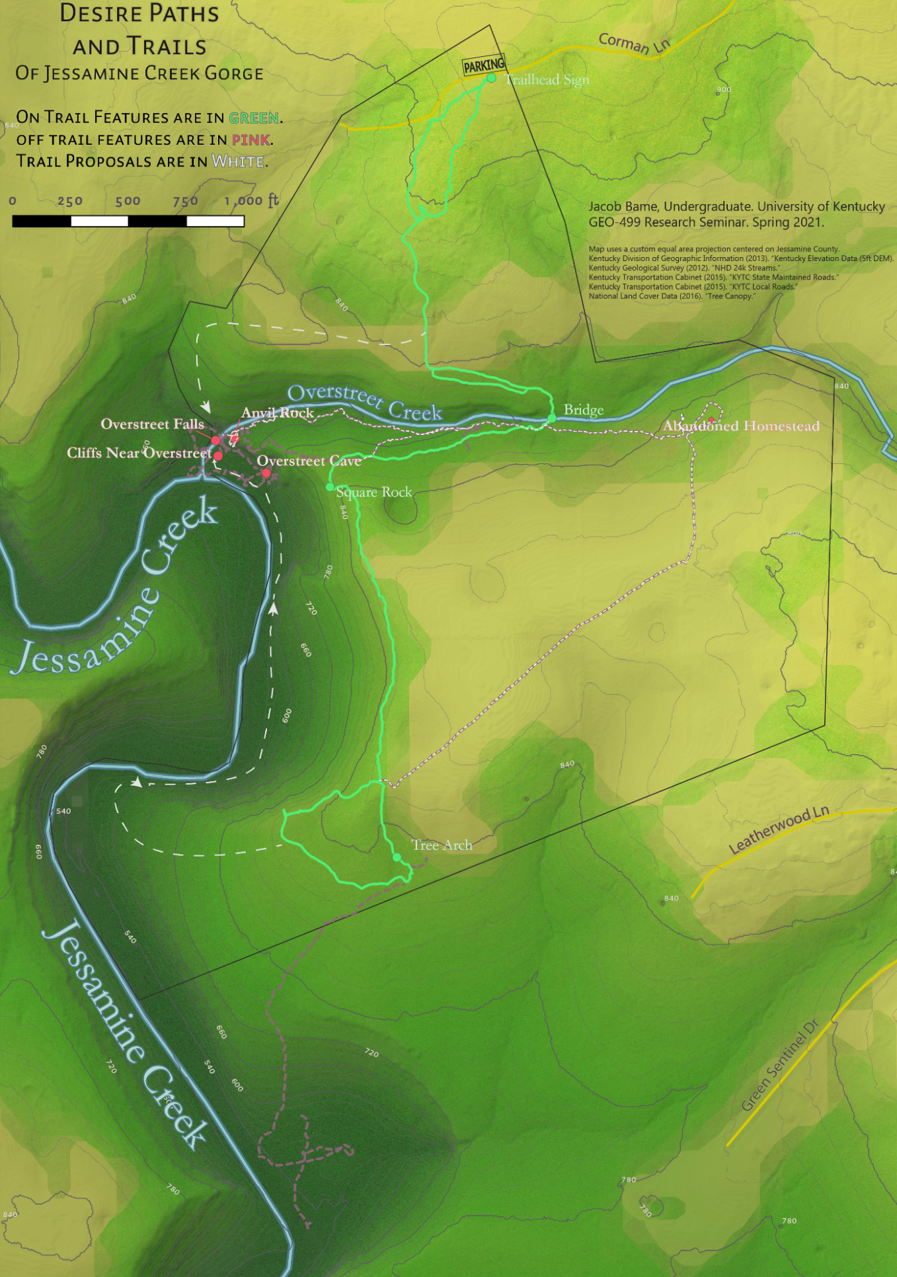  
Figure 4: New Trail Proposal Routes at Jessamine Creek Gorge by Jacob Bame.

**CONCLUSION**

The findings of this research show that desire paths play a major role in the identity of Jessamine Creek Gorge for visitors. This is evident from the quantity of social media posts picturing off-trail features, as well as the efforts put into improving desire paths by visitors. Well maintained desire paths are attracting more traffic to features of interest. Concern remains for protected areas of the preserve, but most visitors simply want to see features of interest. “Desire lines are just that – they are a way of speaking, a way of surveying – a way of making a city our own. They are a place that holds both the past and the present in the space of one footstep, because each footstep that falls follows a hundred earlier feet, while still managing to leave its own impression.” (Luckert, 2012).

There are some additional points to make about my trail proposals. First, these proposals do not consider on-site complications to trail construction and maintenance and are therefore not meant to be taken as proposals for the exact trail location. Terrain obstacles ranging from boulders to trees could result in trail obstruction and would need to be traveled around. Moreover, creating official trails in locations where there were previously none could likely result in new desire paths forming to new features of interest as well. There is an element to trail blazing that cannot be accounted for analytically but can only be determined through on-site action.

Another point to note is that these proposals only consider what routes could exist with the preserve’s current boundaries. As Howard made me aware, Jessamine County owns two similarly sized properties just south of Jessamine Creek Gorge. (Figure 5.) If a small tract of land along Jessamine Creek were to be purchased by the county, the preserve could effectively triple in size and provide all new opportunities for trails and recreation. Moreover, a new entrance to the preserve could be developed off Handy’s Bend Road, which is two lanes and already receives traffic from the sportsman’s league. This would divert traffic away from Corman Lane, ideally resolving the complaints from the road’s residents. There are numerous financial and governmental obstacles that would need to be overcome for this to become a reality. Even so, I hope that the findings of this project provide readers with an imaginative future of Jessamine Creek Gorge, “vivid and affective… of life experiences that are unrestrained by scientific predictions,” governmental ordinances, and economical challenges. (Muenchow, Krüger, 2019. p. 4.)

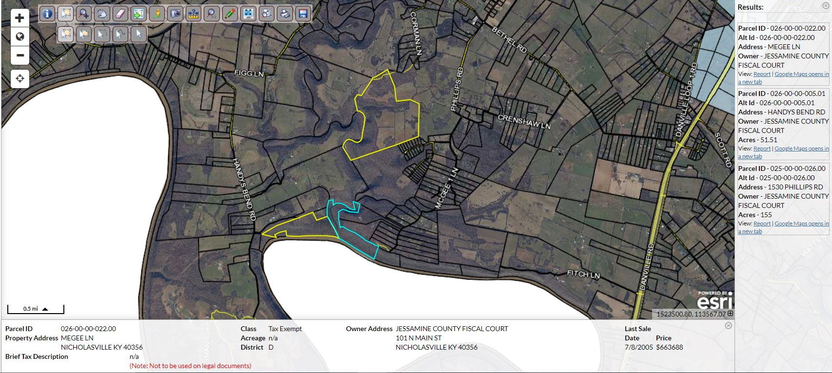  
Figure 5: Properties Along Jessamine Creek Owned by the Jessamine County Fiscal Court

There is a plethora of untapped potential for Jessamine Creek Gorge along with the entire Kentucky River and palisades region in Jessamine County. I firmly believe that the findings of this report indicate that county residents have a desire to find the long-hidden beauty of this area and share it with others in a sustainable manner. With the cooperation of county government and active participation from the community, positive improvements to how Jessamine Creek Gorge is managed and maintained can be put in place today that will have impacts spanning decades into the future.

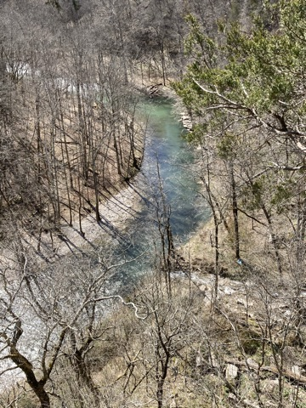

**REFERENCES**

Bramley, E. V. (2018). Desire paths: The illicit trails that defy the urban planners. The Guardian.

Campbell, Julien et. al. 2010. Jessamine Gorge: Biological Inventory. Bluegrass Woodland Restoration Center. http://bluegrasswoodland.com/uploads/Jessamine_Gorge_Report.pdf

Cole, D. N. (2004). Impacts of hiking and camping on soils and vegetation: a review. Environmental impacts of ecotourism, 41, 60.

Farrell, T. A., & Marion, J. L. (2001). Trail impacts and trail impact management related to visitation at Torres del Paine National Park, Chile. Leisure/Loisir, 26(1-2), 31-59.

Florea, L. J., Paylor, R. L., Simpson, L., & Gulley, J. (2002). Karst GIS advances in Kentucky. Geography/Geology Faculty Publications, 8.

Howell, H. H., Jones, M. W., & Kuehne, R. A. (1976). Some of the Effects of Domestic Sewage Discharged into Hickman and Jessamine Creeks in Jessamine County, Kentucky.

Jessamine County PVA Office. 2021. County Property Search and Land Parcels. Schneidercorp. https://beacon.schneidercorp.com/Application.aspx?AppID=864&LayerID=16311&PageTypeID=1&PageID=7208

Kocher, Greg. 2015. Experts encourage Jessamine community to protect its rare plants, animals. Lexington Herald Leader. <https://www.kentucky.com/news/local/article44473209.html>

Luckert, E. (2012). Drawings we have lived: Mapping desire lines in Edmonton. Constellations, 4(1).

Martin, M. E. and Schuurman, N. (2020) ‘Social Media Big Data Acquisition and Analysis for Qualitative GIScience: Challenges and Opportunities’, Annals of the American Association of Geographers. Routledge, 0(0), pp. 1–18. doi: 10.1080/24694452.2019.1696664.

Muenchow, J., Schäfer, S. and Krüger, E. (2019) ‘Reviewing qualitative GIS research—Toward a wider usage of open-source GIS and reproducible research practices’, Geography Compass, 13(6), pp. 1–17. doi: 10.1111/gec3.12441.

Nichols, L. (2014). Social desire paths: An applied sociology of interests. Social currents, 1(2), 166-172.

Patrick, Randy. 2020. Jessamine Creek Gorge access limited. The Jessamine Journal. https://www.jessaminejournal.com/2020/08/13/jessamine-creek-gorge-access-limited/

Rose, Gillian. (2014). On the Relation between ‘Visual Research Methods’ and Contemporary Visual Culture. The Sociological Review (Keele), 62(1), 24-46.

WKYT News Staff. (2019). Hiker rescued hours after 50-foot fall at Jessamine Creek Gorge. WKYT. <https://www.wkyt.com/content/news/Hiker-rescued-after-falling-50-feet-at-Jessamine-Creek-Gorge-511851342.html>